Student Name**: Kaushik Das**

University Roll No**: 10200221056**

Registration No. **: 211020100220020 Of 2021-22**

Course: **B.tech I.T**

Year **- 4th**

College Code and Name**: 102 -- KALYANI GOVERNMENT ENGINEERING COLLEGE**

4. Tree Plantation (10 points)

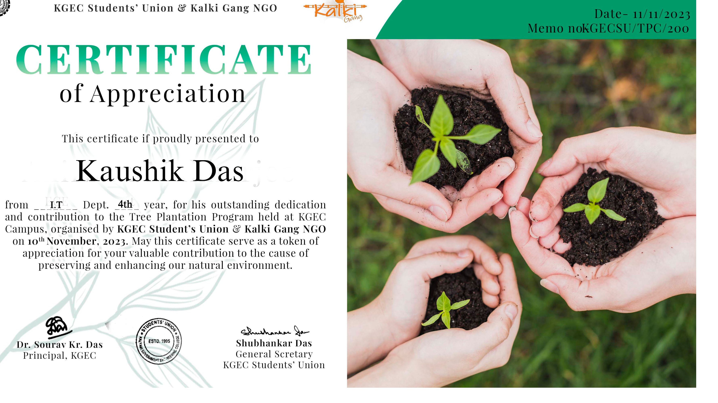

7. Publication in Blogs (10 points)

**URL:** [https://mouse459.blogspot.com/2024/01/lionel-messi-maestro-of-beautiful-game.html 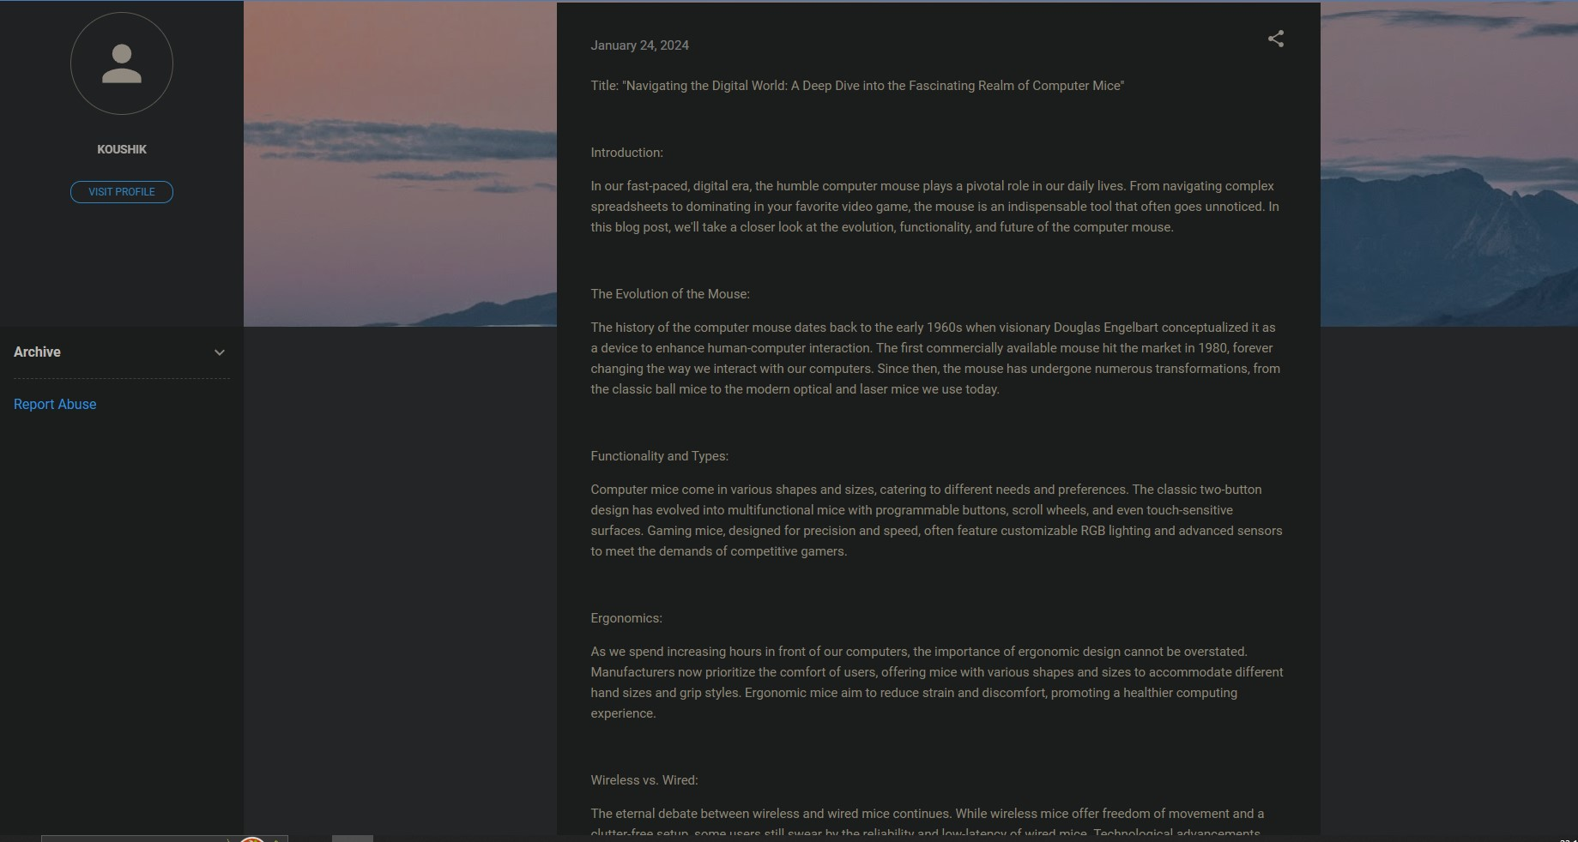](https://anirbanpramanik10.blogspot.com/2024/01/artificial-intelligence.html)

7. Publication in Blogs (10 points)

**URL:** [https://mouse459.blogspot.com/2024/01/lionel-messi-maestro-of-beautiful-game.html](https://anirbanpramanik10.blogspot.com/2024/01/artificial-intelligence.html)

